Napoleon Altitude X-36 & X-42
Deluxe Gas Fireplace

FEATURES - Pro-Flame II Remote - Premium Blower - eFire Bluetooth - Night Lights

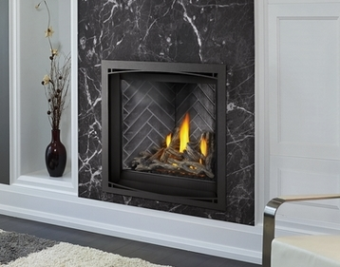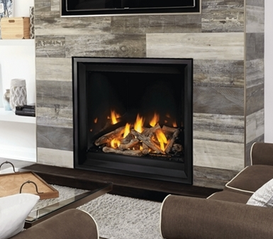
AX36 36,500 BTU’s Shown w/Zen Front & Herringbone Liner Shown Finish Trim & Porcelain Liner

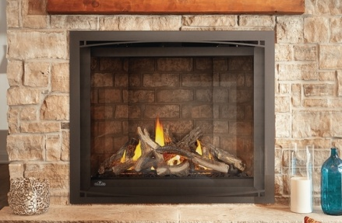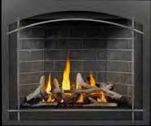
AX42 38,000 BTU’s Shown w/Zen Front & Newport Liner Shown w/Whitney Front & Element, Westminster Liner

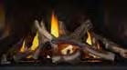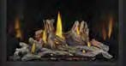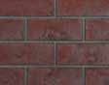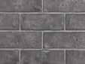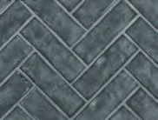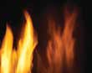
Oak Logs Driftwood Logs Birch Logs Red Brick Grey Westminster Grey Herringbone Newport Mirror-Flame

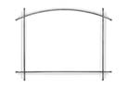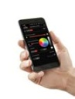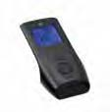
Zen Front Finishing Trim Whitney Front Arched Element eFire Bluetooth Proflame II

• Clean face design with full firebox flame

• Four Ultra HD Premium log set options include: Driftwood, Oak, Birch and Maple

• Zen front available in both Charcoal and Black
• Whitney premium front available with three Element accent colors, Nickel, Pewter and Brass
• Finishing trim available in Charcoal, Black, Gunmetal and Copper

• Six decorative brick kits include MIRRO-FLAME™ Porcelain Reflective Panels, Westminster™Standard and Herringbone, Newport™ Standard, Old Town Red™ Standard and Herringbone

• Exclusive NIGHT LIGHT™
• eFIRE Remote App - total control of your fi replace from your mobile device

• Heat circulating blower with variable speed and thermostatic control provides powerful heating performance comes include

For more info consult with your dealer or Napoleonfireplaces.com

